Our Mission
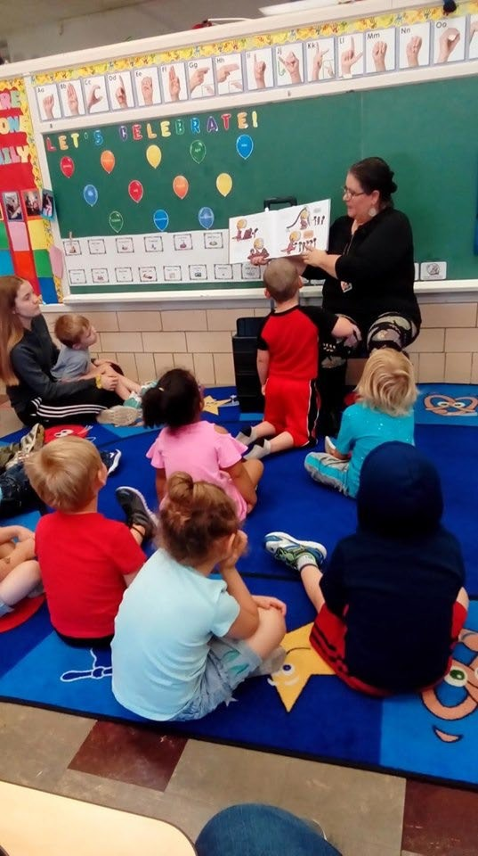
“Coshocton County Head Start Inc. is a comprehensive family and child development program committed to providing quality services that support and nurture the families we serve. Our work connects through our community as we prepare our children for a successful future, in doing so we benefit not only our families, but our broader community as well”
Coshocton County Head Start, Inc.
2018/2019
- Family Engagement
- Evaluating Child Outcomes
- Supporting Transitions
- High Quality Teaching and Learning- This component is comprised of the following four areas:
  - Engaging interactions and Environments
  - Research-based Curricula and Teaching Practices
  - Ongoing Assessment of Child Progress
  - Highly Individualized Teaching and Learning.

The Head Start Approach to School Readiness means that children are ready for school, families are ready to support their children's learning, and schools are ready for children.
Annual Report
School Readiness Plan Coshocton County Head Start has created a School Readiness Plan that outlines numerous components necessary to prepare local children and families for their next educational placement. These components consist of:
    - School Readiness Team
    - School Readiness Goals
    - Staff Development
Curriculum
We use the “High Scope Curriculum” in both our Head Start and Early Head Start classrooms and we use “Partners for a Healthy Baby” curriculum in our Early Head Start home base option.
- The High Scope Infant- Toddler Curriculum is Research- based and child-focused. It uses a carefully designed process of learning through discovery called active participatory learning. During active learning, infants and toddlers learn about the world around them by exploring and playing.
The High Scope Infant-Toddler Curriculum is a comprehensive model that addresses all areas of development through six

content areas and 42 key developmental indicators (KDIs)
— the skills and behaviors at each stage of development that pave the way for school and adult success. Each KDI is connected to and reinforced by scaffolding strategies to support and gently extend children's learning.
- The High Scope Preschool Curriculum is research-based and child- focused, and uses active participatory learning and the plan-do-review process to achieve powerful, positive outcomes.
As teachers, parents, and educational researchers have discovered, the High Scope Curriculum not only helps young children excel in literacy and cognitive learning, but also to develop the fundamental skills that help determine success in adult life.
- The Partners for a Healthy Baby curriculum brings together all the information that home visitors need to work with expectant families and families with young children. This evidenced-based series stresses the importance of prenatal and early childhood development and the power of early family relationships.

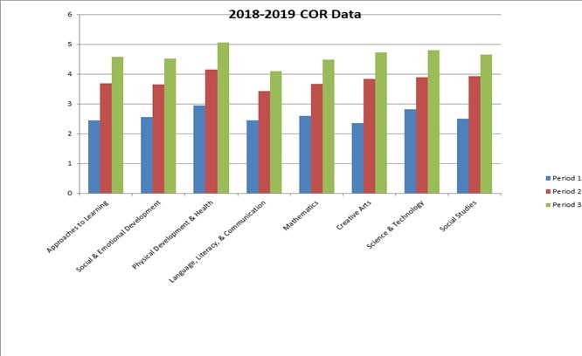
Birth to Five Child Outcomes

Parent Engagement Activities
As their child’s first and most influential teacher, parents have an important role in Head Start. Parents are always welcome in the classroom by helping with or leading activities, attending learning trips, planning classroom activities with the teaching staff, and introducing or sharing their culture with the children. There are a number of ways that parents can help teaching staff by sharing opinions, ideas and thoughts, working on activities at home, communicating with the staff, helping other parents feel welcome, and reinforcing learning at home. In addition, Coshocton County Head Start offers parents the opportunity to participate in the following activities:

- Family Literacy Activities
- Parent Committee Meetings
- Parent/Teacher Conferences
- Home Visits
- Policy Council
- Volunteering
- Resource and Referral Information
- Recruitment
- Family Partnership Agreements
- Input into the Curriculum
- Input into the Curriculum
- Input into Program Planning
- Training
- Parent Café

23 Homeless Children
11 children in Foster Care or Kindship Care

3 Locations

6 Full Day Preschool Classrooms.
4 Full Day Infant/Toddler Rooms

174 Preschool Children
served in Head Start

92 Infants/Toddlers
served in Early Head Start

8 Pregnant Moms Received
Early Head Start Services

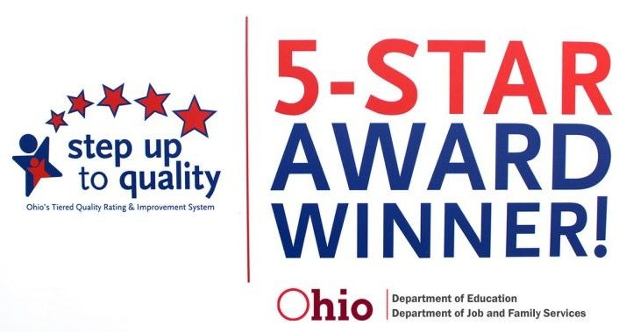
253 or 95 % of Physicals completed
171 HS
82 EHS

243 or 91% of Dentals Completed
156 HS
87 EHS

215 Children up to date with EPSDT Well Child Care
2018 Total Grant Funding:
$2,462,495

In-kind

$615,624
209 Children
below 100% of the federal poverty line
18 Children with IFSP’s
17 Children with IEP’s

Total Cumulative Enrollment 2018/2019
174: Head Start
92: Early Head Start

Average Monthly Enrollment
2018/2019
99.88%: Head Start
98.38%: Early Head Start

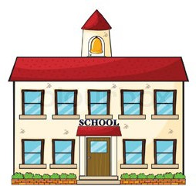
ELIGIBLE CHILDREN SERVED:

HEAD START:
1 OVER INCOME
17 BETWEEN 100% - 130%
90% OF ELIGIBLE CHILDREN SERVED

EARLY HEAD START:
3 OVER INCOME
2 BETWEEN 100% - 130 %
93% OF ELIGIBLE CHILDREN SERVED

Our Financials

Coshocton County Head Start and our local community benefit from federal funding to support Head Start preschool services to 146 children and families, Early Head Start services for 56 pregnant moms, infants, toddlers and their families, and Early Childhood Education for 29 children and families. Funding is based on the 202 available slots; the actual number of children and pregnant moms served in 2017-18 was 247.

2017-18 Funding by Revenue Source: $3,365,266

Federal Head Start | $1,432,770 | Misc. Revenue | $96,514
Federal Early Head Start | $885,886 | USDA | $97,493
Early Childhood Education (State Funding) | $126,128 | Non-Federal Match (In-kind) | $724,925
Capital Campaign Donations | $1,550

2017-18 Expenses: $2,454,688 2018-19 FEDERAL BUDGET: $3,194,119
Food
$100,228
Fringe
Benefit
$411,874
Salary &
Fringe
$1,304,098
Supplies
$86,657
Bus Operations
$54,198

Contractual
$56,608

Training & Travel
$50,480
Other
$390,545
 | Head Start | Early Head  Start | Early Childhood  Education | TOTAL
SALARIES | $871,265 | $619,929 | $73,675 | $1,564,869
FRINGES | $331,811 | $205,603 | $33,313 | $570,727
TRAVEL | $3,611 | $4,682 | $0 | $8,293
FURN. & EQ. | $12,944 | $0 | $0 | $12,944
SUPPLIES | $45,832 | $29,574 | $0 | $75,406
OTHER | $222,845 | $114,399 | $9,012 | $346,256
Estimated Funding | $1,488,308 | $974,187 | $116,000 | $3,194,119
IN-KIND | $372,077 | $243,547 | ----------- | $615,624
TOTAL | $1,860,385 | $1,217,734 | $116,000 | $3,194,119

*Other expenses include: volunteer costs, parent services, publications/advertising/printing, staff costs (including advertising and pre-employment screenings), training and staff development (including college coursework), insurances (bonding, directors’ and officers’ liability, and general liability), and interest expense.
Annual Audit

Coshocton County Head Start is a 501 (C)(3) Non-Profit organization. Julian & Grube conducted our 2018 Audit which is a requirement from Uniform Guidance (§75.501) by the Government Publishing Office. The Auditors check 100% of all Payroll, Account Payables and Deposits. Coshocton County Head Start had no finding in our 2018 Audit.

Program Performance Summary

From March 19-22, 2018, the Administration for Children and Families (ACF) conducted a Monitoring Review of the Coshocton County Head Start program. They reviewed the grantee’s performance and compliance with the requirement of the Head Start Program Performance Standards of Public Law 110-134, Improving Head Start for School Readiness Act of 2007.

The program met all requirements in:
• Program Management
• Program Governance
• ERSEA (eligibility, recruitment, selection, enrollment, and attendance)
• Early Education and Child Development program services
• Health Program Services
• Family and Community Engagement Program Services

There was one Area of Noncompliance 1303.46(b)(3):
The Grantee used federal funds to renovate a facility and did not file a notice of federal interest within the timeframe; therefore, it was not in compliance with the regulation. Timeframe for Correction is 120 days which has been met.

