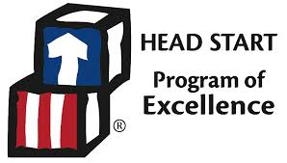

Dear Parents and Guardians:

Coshocton County Head Start and Early Head Start will continue Remote Learning after the holiday break through January. Our hope is to return to Traditional Classroom Learning, but at this time we are uncertain as to when we can do safety. This decision was not easy. After carefully analyzing data and consulting with the local Health Department, we feel it is in the best interest of public health and safety.
The precautionary actions of our school staff, along with the help of our families and the community will be imperative in bringing children back into the classroom. While we cannot guarantee anything, we feel conscientious efforts by everyone will make it possible. It will need to be a team effort between school staff, families, and the community to decrease the spread.
With that said we need your help to ensure the children are receiving the necessary support so they can be successful once Classroom Learning resumes.
While your child is receiving virtual services, our expectations are as follows:
- All parent/guardians are required to login to Class tag at a minimum of 3 times a week
- You must contact your child’s teacher if you are unable to login the required 3 time per week
- Teachers and Family Advocates will be working with families on an individual basis if they are unable to login to Class tag for the required minimum of 3 times per week.
Please remember things can change quickly. As data analysis continues, changes may need to occur. We will continue to communicate information as needed.
We appreciate your continued support, flexibility, and collaboration. Finally, I want to wish everyone a Happy Holidays and a Happy New Year!

Sincerely,

Susan Craddock

