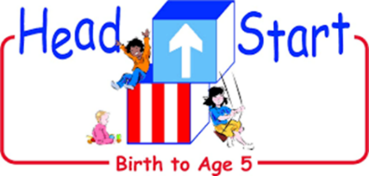

Coshocton County Head Start has worked throughout the pandemic with the Coshocton Health Departments, our Health Advisory Committee and Governing Boards to ensure that we are providing a quality early childhood experience for our students while maintaining a safer and healthiest environment possible.

This plan describes how Coshocton County Head Start, Inc. will maintain the health and safety of students, staff and families during the 2021-2022 school year. We plan to return to In-person instruction on September 7, 2021. We will continue to utilize the re-opening playbook put in place last school year with a few updates.

Maintaining Health & Safety

Face Coverings: To begin the school year and until further notice, face coverings will still be required for Coshocton County Head Start staff, adults entering our buildings and during pick-up and drop-off times (unless the family member can physical distance) in order to promote safety in each building.
10/11/2021 UPDATE: Under guidance from the Coshocton County Health Departments, Coshocton County Board of Directors and input from the Policy Council we will be mandating that all children wear masks in all common areas of our buildings. This includes pick up and drop off, in the hallways coming and going from their classrooms and to the restrooms. Children will not be wearing masks in their classrooms or on the playgrounds at this time as they are in their classroom “pods”.
- The CDC continues to require that masks be worn on all public transportation, including school buses. Since we are unable to social distance on a full bus, students and staff will be required to wear a mask while riding on a school bus. Parents may choose to self-transport their child.
- We will utilize physical distance protocols whenever possible.
- We will utilize CDC guidelines for handwashing by both children and staff.
- We will make hand sanitizer accessible throughout the buildings.
- Cough and sneeze etiquette will continue to be taught, monitored and reinforced.
- Cleaning and Maintaining Healthy Facilities: We will use disinfectant sprayers throughout the facilities and on the buses. We will continue using the cleaning protocol put in place during the 2020-2021 school year.
- Large group gatherings will be minimized.
- Modifications will be made for school meals and for bus transportation to support safety
- guidelines.
- Contract tracing will continue to occur under the guidance of our local Health Departments.
- Coshocton County Head Start updated this plan in August 2021. We will continue to progress monitor and review the procedures in accordance to state and local health guidelines. Coshocton County Head Start will review this plan semi-annually, or as needed. We will use our website and to update any amendment(s) to this document
Coshocton County Head Start will be transparent with all stakeholders that some level of risk will always be present when children and school employees occupy school facilities.
Parents/Guardians have the ultimate decisions of sending their child to school.
Communications/COVID-19
When a student/staff member has been diagnosed with a COVID 19 positive case, persons that were exposed by the positive case will be contacted by the Health Department, not the school.
Coshocton County Head Start will cooperate with the Health Department’s work in social tracing.
The Health Department will determine the length of isolation and quarantine periods necessary for each of the affected persons.
School Visitors/Volunteers
At this time until further notice we are not accepting volunteers or school visits.
Assessing Symptoms
- All staff will have their temperatures taken and will be assessed for symptoms they enter the building. Staff with a temperature over 100 degrees Fahrenheit or symptoms of COVID-19 will be sent home.
- Students will have their temperatures taken and will be assessed for symptoms before they enter the building. Students with a temperature over 100 degrees Fahrenheit or symptoms of COVID-19 will be sent home.
Students who become ill at school and who show symptoms of a possible COVID-19 case, which includes having a temperature, will be placed in a separate room/location, and be supervised by school staff until they are transported home.

Social Distancing
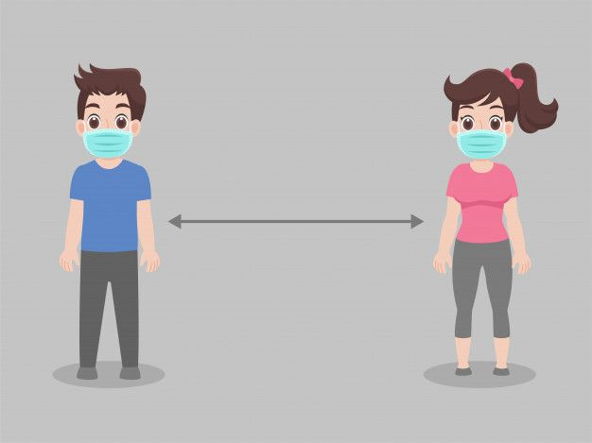

Children: We recognize how difficult it is in early education settings (Birth – 5) to maintain a safe social distance between children. For optimal development, it is important for young children to explore their environments and interact with friends. Understanding the challenges social distancing presents for children in the way we think about it for adults, it is not required for children to remain 6 feet apart. However, the following child social distancing practices will be implemented in programs:
- Adhere to reduced staff to child ratios and maximum group size limitations, following those set by the State of Ohio at all times.
  - At least one child care staff member per four infants and toddlers (1:4) with no more than eight children in the room.
  - At least one child care staff member per ten preschool children (1:10) with no more than 20 children in the room.
  - To the extent possible, try to use separate sinks for each group of students. Measures to disinfect will be taken between each use.
  - To the extent possible, try to use different bathrooms for each group of students. Measures to disinfect will be taken between each use.
- In creating classroom rosters, the same group of children will be together each day, and the same teacher and education support staff should remain with the same group of children each day to help minimize the spread of an infection.
  - Siblings and children of like family, to the extent possible, should be in the same group.
  - Educational support staff, to the extent possible, will only serve one group of children.
- At nap time, ensure that children’s naptime mats (or cribs) are spaced out as much as possible, ideally 6 feet apart. Placing children will be placed head to toe in order to further reduce the potential for viral spread.
- Restrict the use of the playground to only allow one group of children at a time. Follow CDC cleaning guidelines (Disinfection and Cleaning) on how to clean the playground between each group of children will be followed.
- Limit the use of any communal indoor space, such as gross motor rooms, the gym, and common area bathrooms. Measures to disinfect will be taken between each use.
- All special events such as field trips, excursions, and large-group events will be postponed until further notice

Use Signage, tape, or other means to allow for adequate spacing in areas such as classroom areas, number of children at lockers, or when children must wait in line such as bathrooms or hallways.

Staff: Coshocton County Head Start, Inc. Employees must maintain at least a 6-foot distance between one another (if possible) at all times to minimize potential COVID-19 exposure. This distance must be maintained while walking into work, clocking in, during all breaks, etc. (note this is not an all-inclusive list). While all staff are responsible for maintaining a 6-foot distance from one another, administrators will be helping to remind staff members if they notice any deviation from the requirement. The following precautions should be made to help maintain social distancing of staff:
- Breaks should be staggered to have no more than 3 staff utilizing the breakroom at one time.

Modifications to Physical Environments
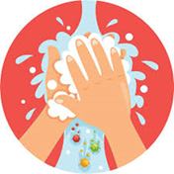

Hygiene Practices: The best way to prevent illness is to avoid being exposed to this virus. The virus is thought to spread mainly from person-to-person; between people who are in close contact with one another (within about 6 feet).

Hand Washing: Children as well as Coshocton County Head Start staff members MUST wash hands with soap and warm water for at least 20 seconds. Staff members are to avoid touching their face with bare or gloved hands. Staff must follow rigorous hand washing procedures as detailed in Appendix B of Ohio Administrative Code 5101:2-12-13.
- Upon arrival for the day, after breaks and upon returning from outside.
- After toileting or assisting a child with toileting.
- After each diaper change or pull-up change.
- After contact with bodily fluids or cleaning up spills or objects contaminated with bodily fluids. (ex. Blowing you or a child’s nose)
- After cleaning or sanitizing or using any chemical products.
- After handling pets, pet cages or other pet objects that have come in contact with the pet.
- Before eating, serving or preparing food or bottles or feeding a child.
- Before and after completing a medical procedure or administering medication.
- When visibly soiled (must use soap and water).
- Prior to departure.

Protective Equipment: Monitor the guidance related to personal protective equipment from the U.S. Centers for Disease Control and Prevention, Ohio Department of Health, and local health authorities. Based on these recommendations, we will require the use of certain personal protective equipment.
It is important to remember that it is still possible to spread germs while wearing protective equipment and that proper use is required to help prevent the spread.

Gloves: Disposable gloves are no substitute for hand washing. Disposable gloves are not required for working unless serving food, preparing bottles, or changing diapers. Gloves should be changed between each new bottle feeding or diapering. Hand hygiene as described above must be practiced with gloved or bare hands. If worn, gloves must be removed without touching the outside of the glove.

Protective Face Coverings
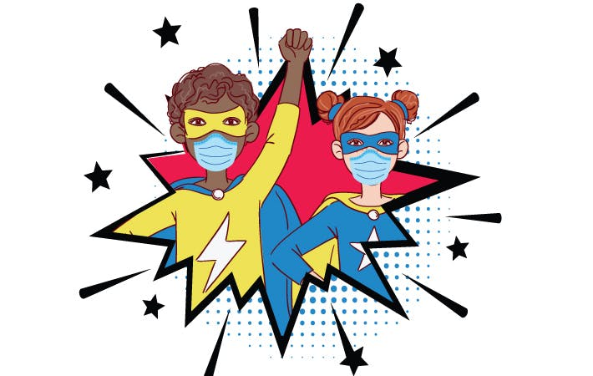
Based on current guidance from the U.S. Centers for Disease Control and Prevention (CDC), the Ohio Department of Health, and Ohio Department of Job and Family Services we are requiring the use of protective face coverings for all Coshocton County Head Start staff members. Staff will be offered reusable protective masks or be required to utilize their own reusable cloth or disposable masks.
Coshocton County Head Start, Inc. employees may use their own face coverings, if they:
- Fit snugly but comfortably against the side of the face, covering the mouth and nose.
- Are secured with ties or ear loops.
- Include multiple layers of fabric.
- Allow for breathing without restriction.
- Can be laundered and machine dried without damage or change to shape.
Coshocton County Head Start, Inc. employees are responsible for the cleaning and care of reusable masks provided by the program or face coverings they secure on their own.
When does the Ohio Department of Health Director’s Order to wear a facial Covering not apply?
- The Individual has a medical condition that contraindicates the wearing of a facial covering including:
- Medical condition, including respiratory conditions that restrict breathing
- Mental Health condition
- Disability
- An individual is seated and actively consuming food or beverage.
- An individual is alone in an enclosed space, such as an office.
Please direct any questions about a staff member’s ability to wear a mask to the Executive Director.
Staff who are in direct contact with children should bring an extra set of clothes to leave at work in case of an emergency.

Training to Apply a Face Mask
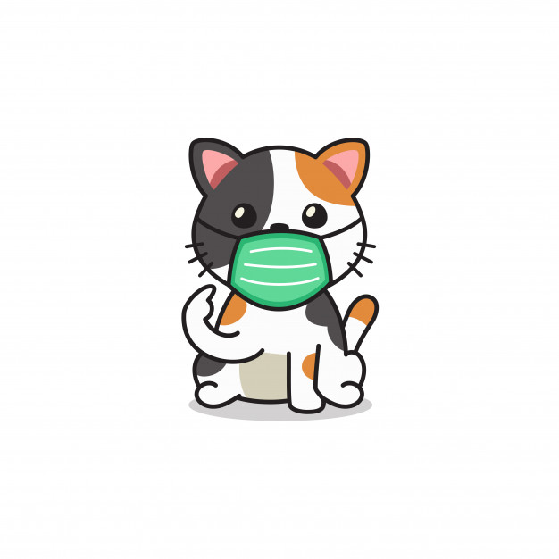
- Before touching or applying a face mask, individuals should wash their hands with soap and warm water for at least 20 seconds or use hand sanitizer to clean hands thoroughly.
- Ensure the face mask is positioned with the stiff, bendable edge (if present) at the top and with the folded layer and ear loop fasteners, elastic bands, or tie-on fasteners on the outside of the face mask.
- For face masks with ear loop fasteners, hold the face mask by the ear loops and place a loop around each ear. Next, secure the nosepiece comfortably over the bridge of the nose by molding or pinching the stiff edge.
- For face masks with elastic straps, place the mask on the face and stretch the lower strap over the head and below the ears, and the upper strap over the head and above the ears.
- For face masks with tie-on fasteners, bring the face mask to nose level, place the ties over the crown of the head, and secure with a bow. Next, secure the nosepiece comfortably over the bridge of the nose by molding or pinching the stiff edge. Take bottom ties, one in each hand, and secure with a bow at the nape of the neck.
- Pull the bottom of the face mask down over the mouth and chin.

To Remove a Face Mask
- Before removing a face mask, individuals should wash their hands with soap and warm water for at least 20 seconds or use hand sanitizer to clean hands thoroughly.
- Avoid touching the front of the face mask as it may be contaminated. Only the ear loops, elastic straps, or ties should be touched during removal.
- After removing the mask, wash hands with soap and warm water for at least 20 seconds or use hand sanitizer to clean hands thoroughly.

Disinfection and Cleaning
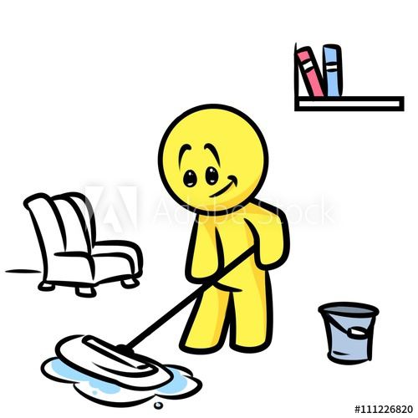

Classroom Staff will assist in keeping classrooms safe and clean. Staff will clean and disinfect children’s work areas throughout the day, and provide a thorough disinfecting before drop off and after pick up. Teachers should remove toys after each use and place them in a tub to be sanitized after class. Toys made of fabric/cloth and dress up materials must be removed from the classroom permanently. Paperback books will be rotated daily from the classrooms allowing books five days before being reintroduced to the room. Books that can easily be wiped down can be left in the room.

CCHS staff members are responsible for frequently cleaning and disinfecting areas in which they work and that are commonly touched. Examples of these commonly touched areas include desks/workstation surfaces, keyboards, phones, printers and copiers. This is not an all-inclusive list. Check with your supervisor for additional duties, and fill out checklist as requested.

Janitorial Staff will clean and disinfect common areas like the break rooms, bathrooms, stairs and railings. Areas will be sanitized often throughout the day.

Cleaning Procedures
- Wear disposable gloves to clean and disinfect.
- Clean surfaces using soap and water, then use disinfectant.
- Cleaning with soap and water reduces the number of germs, dirt and impurities on the surface. Disinfecting kills germs on surfaces.
- Wash the surface or item with a detergent solution or other appropriate commercial product used for cleaning purposes. Questions about products must be directed to the manufacturer of the product. Follow the manufacturer’s instructions exactly.
- Practice routine cleaning of frequently touched surfaces.
  - Tables, doorknobs, light switches, countertops, handles, desks, phones, keyboards, toilets, faucets, sinks, etc.

Disinfect
- Centers must use a sanitizer that has directions for use that are appropriate for the surface or item you are sanitizing.
- Diluted household bleach solutions may also be used if appropriate for the surface.
- Bleach solutions will be effective for disinfection up to 24 hours.
- Alcohol solutions with at least 70% alcohol may also be used.
Soft Surfaces: such as carpeted floor, rugs, and drapes.
- Clean the surface using soap and water or with cleaners appropriate for use on these surfaces.
- Launder items (if possible) using the warmest appropriate water setting and dry items completely.
- Disinfect with use of EPA-registered household disinfectant.
- Vacuum as usual.

Electronics: such as tablets, touch screens, keyboards, and remote controls.
- Consider putting a wipeable cover on electronics.
- Follow manufacturer’s instructions for cleaning and disinfecting.
- If no guidance, use alcohol-based wipes or sprays containing at least 70% alcohol. Dry surface thoroughly.

Laundry: For clothing, towels, linens and other items
- Use the warmest appropriate water setting and dry items completely.
- Wear disposable gloves when handling dirty laundry.
- Do not shake dirty laundry.
- Clean and disinfect clothes hampers according to guidance above for surfaces.
- Remove gloves and wash hands right away.

Cleaning and Disinfecting Outdoor Areas and Playgrounds
- Outdoor areas, like playgrounds, require normal routine cleaning.
- High touch surfaces made of plastic or metal, such as grab bars and railings should be cleaned routinely.

Cleaning and Disinfecting Common Spaces
- Regular cleaning staff can clean and disinfect community spaces.
  - Ensure they are trained on appropriate use of cleaning and disinfection chemicals.
- Wear disposable gloves for all tasks in the cleaning process, including handling trash.
  - Gloves should be removed carefully to avoid contamination of the wearer and the surrounding area.
- Wash your hands often with soap and water for 20 seconds.
  - Always wash immediately after removing gloves and after contact with a person who is sick.
  - Hand sanitizer: If soap and water are not available and hands are not visibly dirty, an alcohol-based hand sanitizer that contains at least 70% alcohol may be used. However, if hands are visibly dirty, always wash hands with soap and water.

Drop Off and Pick-Up
Early Head Start: Families will meet at the child’s classroom external door at their designate drop off time, which will be given to them by a staff member. FAMILIES MUST KEEP THEIR TIME! These doors are located behind the building. Parents and family members will not be allowed inside the building and must wear a mask during drop off and pick up. Only one adult will be allowed to accompany the child to the door. If possible, the same adult should conduct pick up and drop off each day.
Upon your arrival to pick up your child, a staff member will meet you outside the external classroom door. Only one parent is permitted to be at the door at a time, please wait in your car until a staff member motions to you that it is your turn. Please allow for extra drop off and pick up time to ensure you are not late for work or your next appointment
Head Start: Families will meet at the entrance of the building at their designated drop off time, which will be given to them by a staff member. FAMILIES MUST KEEP THEIR TIME! Parents and family members will not be allowed inside the building and must wear a mask during drop off and pick up. Only one adult will be allowed to accompany the child to their teacher. If possible, the same adult should conduct pick up and drop off each day. Please wait in your car until it is your turn to deliver your child to their teacher.
Pick Up: Your child’s class will be outside at the designated area. Only on parent is permitted pick up their child. The family member should wait in their car until it is your turn. The family member should allow for extra drop off and pick up time to ensure they are not late for work or their next appointment

Child Daily Health Check and Temperature screening:
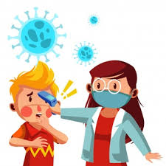
Prior to the parent leaving the site a trained staff member will take the temperature of the child following the manufacturer’s directions and ask parents the following questions:
  - Do you live with anyone or have you had close contact with anyone who has been diagnosed with COVID-19 within the past 14 days?
  - Do you or anyone in your household have a fever, cough and/or shortness of breath?
  - Do you or your child(ren) have any other signs of communicable illness such as a cold or flu?

The staff member conducting the temperature screening must wear gloves and a face mask at all
times while conducting temperature screenings.

All results must be kept confidential and should not be disclosed verbally while other families and staff members are nearby. The program will not retain or store temperature records.

If a child's temperature registers at 100 degrees Fahrenheit or higher, you must take your child

home. The child cannot return to school until they have been fever free for a minimum of

24 hours without the use of fever-reducing medications.

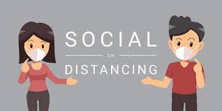
STAFF

Staff Daily Health Check including temperature screening
Following the guidance of government officials to maintain a safer work environment, the following procedures should be required daily when Coshocton County Head Start, Inc. staff members report to work:
- Employees must be sure to follow the thermometer temperature screening procedure for staff each day.
- The state mandates that temperatures of all staff, children, and adults should be taken upon arrival. If any individual has a fever of 100 degrees or higher, they may not enter the facility.
- Temperature screenings will be completed by the Health staff and/or management.
- If Coshocton County Head Start, Inc. staff members have to wait in line for the temperature check, ensure they are maintaining social distancing (6 feet apart).
- All results must be kept confidential and should not be disclosed verbally while other administrative staff, teachers or education support staff members are nearby. The program will not retain or store temperature records.
- The Health staff and/or management conducting the temperature screening must wear gloves and a face mask at all times while conducting temperature screenings.
- A touchless thermometer (forehead/ temporal artery thermometer) whenever possible, but if you must use oral or another type of thermometer, make sure to clean it thoroughly between each use.
- Follow the manufacturer’s directions to disinfect the thermometer.
- To conduct the screening, use the instructions provided by the thermometer’s manufacturer

