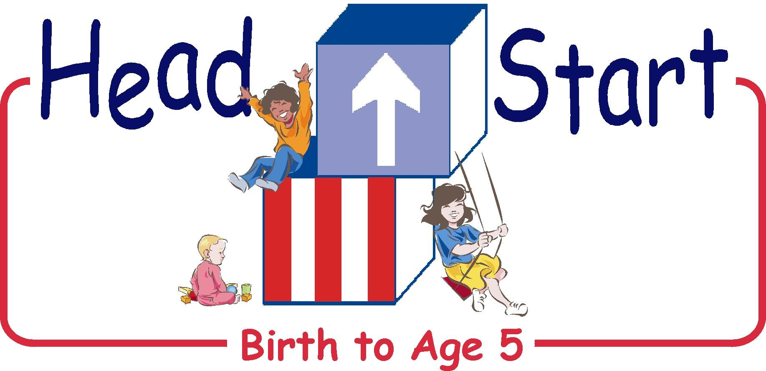

January 19, 2021

Coshocton County Head Start & Early Head Start Families,

I hope this letter finds you and your family well.
With consultation from the County Health Department and Health & Safety protocols in place we will be welcoming students back to their Early Head Start/Preschool classrooms on Monday, January 25th. We are very excited about getting the children back to school. We have missed their smiles and laughter.
We are all aware that COVID continues to be a serious issue in our country, state, and local community. At school we will continue to social distance, require face coverings for staff, take temperatures daily, use increased disinfecting practices, and promote frequent hand washing/hand sanitizer throughout our school buildings.
Since we serve children under 5 and we do not require the students to wear masks, we will still be following our previous quarantine protocol.
As we continue through this challenging school year, please know that we are here to assist and support our families in any way that we can.
Please refer to our “Re-opening Playbook” for information as needed.
We Wish You Well,

Susan Craddock
Executive Director

